**Drinks Menu**

**Dataset Description:**

The data shows Menu of Drinks with its ingredients. There are 242 observation with 18 variables for each Drink

**Research Questions**

* Q1- Which drink has the highest calories from the dataset?
* Q2. Highest Sugar Drink?
* Q3. What are the average amount of fat in each category?
* Q4. Which features affect on calories ?

**Libraries Use**

* NumPy
* Pandas
* Matplotlib
* Seaborn

**Project Motivation**

The motivation behind the project is to study and understand the best drinks in terms of calories, sugar and health.

**Instructions on how to run the solution**

In my repository, you can find jupyter notebook of this project called “DrinksMenu.ipynb”, a pdf contain screenshots from the notebook called ” DrinksMenu - Jupyter NotebookScreenShoots.pdf” and csv file that contain dataset called “drinkMenu.csv”.

All you want to do to run this notebook, you should put the csv file and notebook in the same folder and run notebook file through jupyter notebook app.

**Answering the researched Questions**

First we start with data preparation stage in which we take care and deal with duplicates, null values and columns types to get best insights from all columns, then we start to use visualization to answer the question through

* Q1- Which drink has the highest calories from the dataset?

We grouped by beverage and get mean of calories for each drink

White Chocolate Mocha (Without Whipped Cream)

has highest calories

To be more certain about the highest calories drink we take in consideration beverage preparation columns as this preparation could affects on the amount of calories in the drink, So we merge each drink with its preparation in new column called “Beverage with preparation” and group by this column using average amount of calories

We found that White Chocolate Mocha (Without Whipped Cream) Venti Nonfat Milk has highest calories.

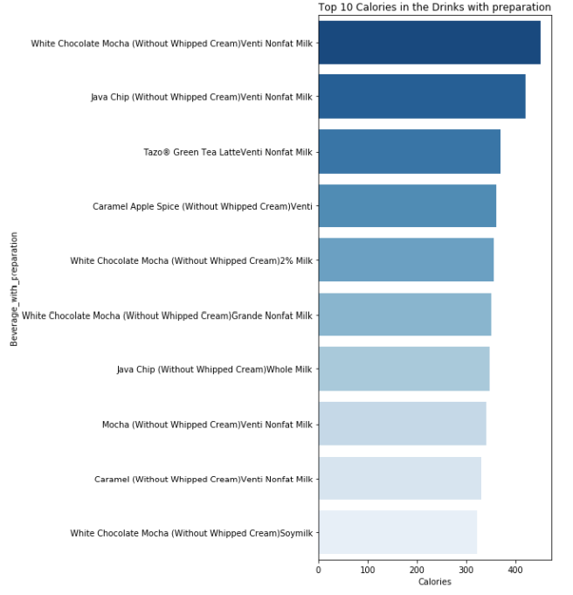

* Q2. Highest Sugar Drink?

We used the same technique used in the first question and get the highest sugar drink which was **Java Chip (Without Whipped Cream)**  and we take in consideration preparation way it can affect on the amount of sugar in the drink and we found that the highest drink was **Java Chip (Without Whipped Cream) Venti Nonfat Milk**

* Q3. What are the average amount of fat in each category?
* We used beverage category column to know the average amount of fats in each category

* Q4. Which features affect on calories ?
  + We used correlation between calories and the other feature and we found that Cholesterol, Sugars and Carbohydrates has the highest correlation to calories of the drinks

**Summary**

* -There are 242 types of drinks with 18 features as Calories, Trans Fat, Cholesterol, Beverage Preparation Type, Beverage Category and so on.
* -if You are on diet, you should avoid high calories drink like White Chocolate Mocha (Without Whipped Cream) and high sugar drink as Java Chip (Without Whipped Cream)
* For your health avoid drinks with high Cholesterol, Sugars and Carbohydrates
* -Signature Espresso Drinks are the highest category that have high average amount of fats